**Complex Assignment**

**Exercise Questions**

1. Write a MongoDB query to display all the documents in the collection restaurants.

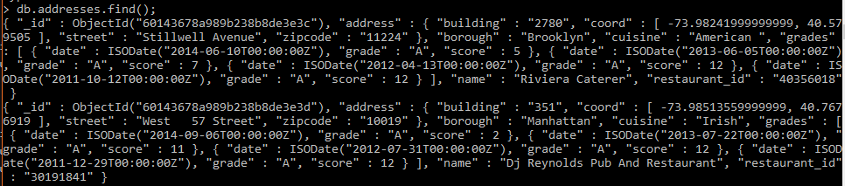

1. Write a MongoDB query to display the fields restaurant_id, name, borough and cuisine for all the

documents in the collection restaurant.

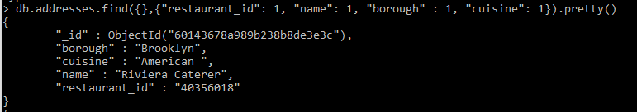

1. Write a MongoDB query to display the fields restaurant_id, name, borough and cuisine, but exclude the field _id for all the documents in the collection restaurant.

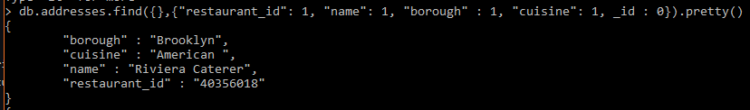

1. Write a MongoDB query to display the fields restaurant_id, name, borough and zip code, but exclude the field _id for all the documents in the collection restaurant.

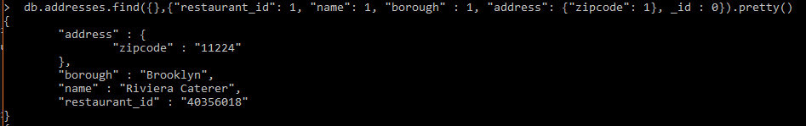

1. Write a MongoDB query to display the first 5 restaurant which is in the borough Bronx.



1. Write a MongoDB query to display all the restaurant which is in the borough Bronx.



1. Write a MongoDB query to display the next 5 restaurants after skipping first 5 which are in the borough Bronx.

db.addresses.find({borough:"Bronx"}).skip(5).limit(5)

1. Write a MongoDB query to find the restaurants who achieved a score more than 90.

db.addresses.find({'grades.score' : {$gt : 90}})

1. Write a MongoDB query to find the restaurants that achieved a score, more than 80 but less than 100.

db.addresses.find({'grades.score' : {$gt : 80}, 'grades.score' : {$lt: 100}})

1. Write a MongoDB query to find the restaurants which locate in latitude value less than -95.754168

db.addresses.find({'address.coord':{$lt : -95.754168}})

1. Write a MongoDB query to find the restaurants that do not prepare any cuisine of 'American' and their grade score more than 70 and latitude less than -65.754168.

db.addresses.find({"cuisine":{$not: {$regex: "American"}}, 'grades.score':{$gt: 70}, 'address.coord.0':{$lt: -65.754168}})

1. Write a MongoDB query to find the restaurants which do not prepare any cuisine of 'American' and achieved a score more than 70 and located in the longitude less than -65.754168.

db.addresses.find({'address.coord.1':{$lt: -65.754168}})

1. Write a MongoDB query to find the restaurants which do not prepare any cuisine of 'American ' and achieved a grade point 'A' not belongs to the borough Brooklyn. The document must be displayed according to the cuisine in descending order.

db.addresses.find({"cuisine":{$not: {$regex: "American"}}, 'grades.grade': {$eq: "A"}, 'borough': {$not : {$regex: "Brooklyn"}} }).sort({'cuisine': -1})

1. Write a MongoDB query to find the restaurant Id, name, borough and cuisine for those restaurants which contain 'Wil' as first three letters for its name

db.addresses.find({'name':{$regex: /^Wil.*/}}, {'restaurant_id': 1, 'name': 1, 'borough': 1, 'cuisine':1}).

1. Write a MongoDB query to find the restaurant Id, name, borough and cuisine for those restaurants which contain 'ces' as last three letters for its name.

db.addresses.find({'name':{$regex: /.*ces$/}}, {'restaurant_id': 1, 'name': 1, 'borough': 1, 'cuisine':1})

1. Write a MongoDB query to find the restaurant Id, name, borough and cuisine for those restaurants which contain 'Reg' as three letters somewhere in its name.

db.addresses.find({'name':{$regex: /.*Reg.*/}}, {'restaurant_id': 1, 'name': 1, 'borough': 1, 'cuisine':1})

1. Write a MongoDB query to find the restaurants which belong to the borough Bronx and prepared either American or Chinese dish.

db.addresses.find({'borough': 'Bronx', 'cuisine':{$in : ['American','Chinese']}})

1. Write a MongoDB query to find the restaurant Id, name, borough and cuisine for those restaurants which belong to the borough Staten Island or Queens or Bronxor Brooklyn.

db.addresses.find({'borough': {$in: ['Staten Island', 'Queens', 'Bronxor Brooklyn']}}, {'restaurant_id': 1, 'name': 1, 'borough':1, 'cuisine': 1})

1. Write a MongoDB query to find the restaurant Id, name, borough and cuisine for those restaurants which are not belonging to the borough Staten Island or Queens or Bronxor Brooklyn.

db.addresses.find({'borough': {$not: {$in : ['Staten Island', 'Queens', 'Bronxor Brooklyn']}}}, {'restaurant_id': 1, 'name': 1, 'borough':1, 'cuisine': 1})

1. Write a MongoDB query to find the restaurant Id, name, borough and cuisine for those restaurants which achieved a score which is not more than 10

db.addresses.find({'grades.0.score':{$lt: 10}, 'grades.1.score':{$lt: 10}, 'grades.2.score':{$lt: 10}, 'grades.3.score':{$lt: 10}}, {'restaurant_id': 1, 'name': 1, 'borough':1, 'cuisine': 1})

1. Write a MongoDB query to find the restaurant Id, name, borough and cuisine for those restaurants which prepared dish except 'American' and 'Chinees' or restaurant's name begins with letter 'Wil'.

db.addresses.find({$or:[{'cuisine':{$not:{$in: ['American', 'Chinese']}}}, {'name': {$regex: /^Wil.*/}} ]}, {'restaurant_id': 1, 'name': 1, 'borough':1, 'cuisine': 1})

1. Write a MongoDB query to find the restaurant Id, name, and grades for those restaurants which achieved a grade of "A" and scored 11 on an ISODate "2014-08-11T00:00:00Z" among many of survey dates..

db.addresses.find({'grades.grade':'A', 'grades.date': {$eq: new Date('2014-08-11T00:00:00Z')}, 'grades.score': {$eq: 11}}, {'restaurant_id': 1, 'name': 1, 'grades':1})

1. Write a MongoDB query to find the restaurant Id, name and grades for those restaurants where the 2nd element of grades array contains a grade of "A" and score 9 on an ISODate "2014-08-11T00:00:00Z"

db.addresses.find({'grades.1.grade':'A', 'grades.1.date': {$eq: new Date('2014-08-11T00:00:00Z')}, 'grades.1.score': {$eq: 9}}, {'restaurant_id': 1, 'name': 1, 'grades':1})

1. Write a MongoDB query to find the restaurant Id, name, address and geographical location for those restaurants where 2nd element of coord array contains a value which is more than 42 and upto 52..

db.addresses.find({$and : [{'address.coord.1': {$gt: 42}}, {'address.coord.1': {$lte: 52}}]},{'restaurant_id':1, 'name':1, 'address':1}).sort({'address.coord': -1})

1. Write a MongoDB query to arrange the name of the restaurants in ascending order along with all the columns.

db.addresses.find().sort({'name': 1})

1. Write a MongoDB query to arrange the name of the restaurants in descending along with all the columns.

db.addresses.find().sort({'name': -1})

1. Write a MongoDB query to arranged the name of the cuisine in ascending order and for that same cuisine borough should be in descending order

db.addresses.aggregate([{$sort: {'cuisine': 1, 'borough':-1}}]).

1. Write a MongoDB query to know whether all the addresses contains the street or not.

db.addresses.find({'address.street': {$exists: true}}).pretty() >= db.address.find()

1. Write a MongoDB query which will select all documents in the restaurants collection where the coord field value is Double.

db.addresses.find({'address.coord': {$type: 'double'}})

1. Write a MongoDB query which will select the restaurant Id, name and grades for those restaurants which returns 0 as a remainder after dividing the score by 7.
2. Write a MongoDB query to find the restaurant name, borough, longitude and attitude and cuisine for those restaurants which contains 'mon' as three letters somewhere in its name.

db.addresses.find({'name':{$regex: /.*mon.*/}},{'name':1, 'borough':1, "address.coord":1, 'cuisine':1})

1. Write a MongoDB query to find the restaurant name, borough, longitude and latitude and cuisine for those restaurants which contain 'Mad' as first three letters of its name.

db.addresses.find({'name':{$regex: /.*^Mad/}},{'name':1, 'borough':1, "address.coord":1, 'cuisine':1})